**PostgreSQL Incompatible Action Item with Solution**

|  |
| --- |
| **Issue 7795**: In PostgreSQL, string operations are case sensitive |

Following **Views** are having Issue of case sensitivity from Assessment Report.

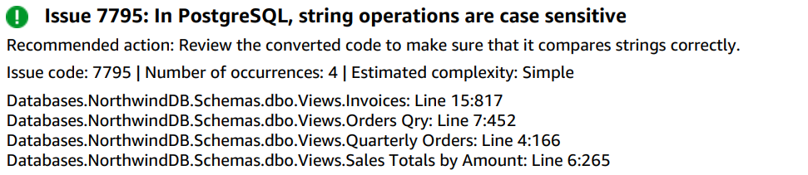

|  |
| --- |
| **Solution:** LOWER() |

For the case sensitivity we can resolve by using LOWER() function surrounding columns. Following is the example.

For the view: "Orders Qry"

INNER JOIN northwinddb_dbo.orders

ON **LOWER(**customers.customerid**)** = **LOWER(**orders.ix_orders_customerid**)**;

|  |
| --- |
| **Issue 7674**: AWS SCT can't convert unknown clauses |

Following **Stored Procedure** are having Issue of unknown clause from Assessment Report.

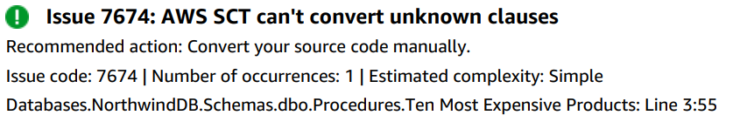

|  |
| --- |
| **Solution**: LIMIT Clause |

The solution for unknow clause that is “SET ROWCOUNT 10” we can use LIMIT Clause instead in the PostgreSQL. Limit does the same functionality as SET ROWCOUNT does.

**For example**:

Existing Procedure:

create procedure "Ten Most Expensive Products" AS

**SET ROWCOUNT 10**

SELECT Products.ProductName AS TenMostExpensiveProducts, Products.UnitPrice

FROM Products

ORDER BY Products.UnitPrice DESC;

Modified Procedure: PostgreSQL Compatible Procedure

CREATE OR REPLACE PROCEDURE northwinddb_dbo."Ten Most Expensive Products"(INOUT p_refcur refcursor)

AS

$BODY$

BEGIN

/*

[7674 - Severity CRITICAL - AWS SCT can't convert the ROWCOUNT clause of the SET statement. Convert your source code manually.]

SET ROWCOUNT 10

*/

OPEN p_refcur FOR

SELECT

products.productname AS tenmostexpensiveproducts, products.unitprice

FROM northwinddb_dbo.products

ORDER BY products.unitprice DESC NULLS LAST

**LIMIT 10;**

END;

$BODY$

|  |
| --- |
| **Issue 7795**: In PostgreSQL, string operations are case sensitive |

Following **Stored Procedure** are having Issue of case sensitivity from Assessment Report.

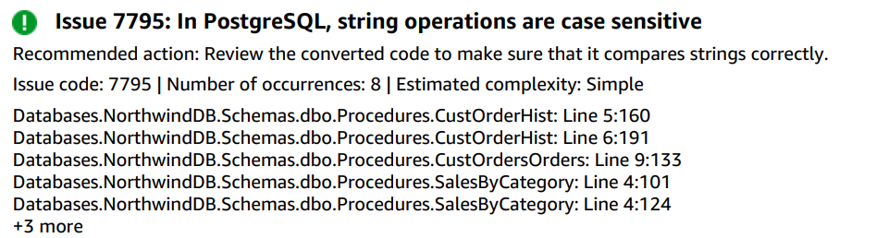

|  |
| --- |
| **Solution:** LOWER() |

For the case sensitivity we can resolve by using LOWER() function surrounding columns. Following is the example.

Existing Procedure:

CREATE PROCEDURE CustOrdersOrders @CustomerID nchar(5)

AS

SELECT OrderID,

OrderDate,

RequiredDate,

ShippedDate

FROM Orders

WHERE **CustomerID = @CustomerID**

ORDER BY OrderID;

Modified Procedure:

CREATE OR REPLACE PROCEDURE northwinddb_dbo.custordersorders(IN par_customerid CHAR, INOUT p_refcur refcursor)

AS

$BODY$

BEGIN

OPEN p_refcur FOR

SELECT

orderid, orderdate, requireddate, shippeddate

FROM northwinddb_dbo.orders

WHERE **LOWER(customerid) = LOWER(par_CustomerID)**

ORDER BY orderid NULLS FIRST;

END;

$BODY$

LANGUAGE plpgsql;